Buckling of Columns
When long, slender structural member is loaded axially in compression, it may bend and deflect laterally and fail instead of failing by direct compressive stress. This is known as failure of columns by buckling.

Stability of columns with pinned ends
Consider a slender column with pinned ends. The column is loaded with a vertical force P that is aligned through the centroid of the cross section and aligned with the longitudinal axis of the column. The column is perfectly straight and is made of linear elastic material that follows Hooke’s law. Assume that the bending takes place in the x-y plane.
When the axial force is small, the column remains straight and undergoes only axial compression. The uniform compressive stress developed in the cross section $σ=\frac{P}{A}$. In this case, if a small lateral load is given to the column, it will cause bending of the column but will disappear once the load is removed. The column is stable equilibrium.
As the axial load P is gradually increased, we reach a condition of neutral equilibrium in which the column may have a bent shape. The corresponding value of the load is the critical load $P_{cr}$. At this load the ideal column may undergo small lateral deflections with no change in the axial force, and a small lateral load will produce a bent shape that does not disappear when the lateral load is removed. Thus, the critical load can maintain the column in static equilibrium either in a straight position or in a slightly bent position. At higher values of the load, the column becomes unstable and collapse by bending. | 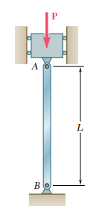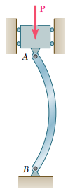

EULER’S COLUMN THEORY
Consider the section of the column AQ as shown. Let y be the deflection of the column at a distance x from A. From the free body diagram,  $${ΣF_{y}=0 ≫≫ P}^{'}=P$$  $$ΣM_{z}=0 ≫≫ M+Py=0≫M=-Py$$  The deflection equation is $EI\frac{d^{2}y}{dx^{2}}=M$  $$EI\frac{d^{2}y}{dx^{2}}=-Py$$  $$\frac{d^{2}y}{dx^{2}}+\frac{P}{EI}y=0$$ | 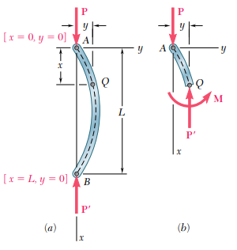
This is a second order linear homogeneous differential equation with constant coefficients. This is of the form $\frac{d^{2}y}{dx^{2}}+ω^{2}y=0,$where$ω=\sqrt{\frac{P}{EI}}$ . The solution of this differential equation is  $$y=A\sin{ωx+B\cos{ωx=A\sin\left(\sqrt{\frac{P}{EI}}\right) x+B\cos\left(\sqrt{\frac{P}{EI}}\right) x}}$$  Substituting the boundary conditions  When $x=0, y=0≫≫≫0=B$  When $x=L, y=0≫≫≫0=A \sin\left(\sqrt{\frac{P}{EI}}\right) L$ |  | 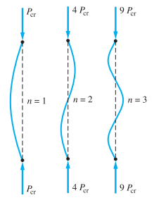
$$\sin\left(\sqrt{\frac{P}{EI}}\right) L=0≫≫\left(\sqrt{\frac{P}{EI}}\right)L=nπ (n=0,1,2..)$$
$$P_{cr}=\frac{n^{2}π^{2}EI}{L^{2}}$$
Taking $n=1$,
$$P_{cr}=\frac{π^{2}EI}{L^{2}}$$

$$σ_{cr}=\frac{P_{cr}}{A}=\frac{π^{2}E(Ak^{2})}{AL^{2}}=\frac{π^{2}E}{{\left(\frac{L}{k}\right)}^{2}}$$

$k$ is the radius of gyration of the cross section about the buckling axis and $\left(\frac{L}{k}\right)$ is known as the Slenderness ratio.  In the case of a column with a circular or square cross section, the moment of inertia I of the cross section is the same about any centroidal axis, and the column is likely to buckle in one plane as another, except for the restraints that can be imposed by the end connections. For other shapes of cross section, the critical load should be computed by using the minimum value of the moment of inertia. Buckling will take place in a plane perpendicular to the corresponding principal axis of inertia. | 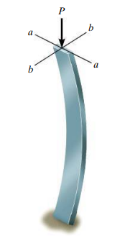

#Example 1
A 2 m long pin-ended column of square cross section is to be made of wood. Assuming $E=13 GPa$, $σ_{allow}=12 MPa$, and using a factor of safety of $2.5$ in computing Euler’s critical load for buckling, determine the size of the cross section if the column is to support (a) a $100 kN$ load, (b) a $200 kN$ load.
a)  $$P_{cr}=FoS×100 kN=2.5×100 kN=250 kN$$  $$L=2m ≪≫ E=13×{10}^{9} Pa ≪≫ I=\frac{a^{4}}{12}$$  $$P_{cr}=\frac{π^{2}EI}{L^{2}}=\frac{π^{2}E\left(\frac{a^{4}}{12}\right)}{L^{2}}$$ | $$a^{4}=\frac{12(250×{10}^{3} N)({2m)}^{2}}{π^{2}(13×{10}^{9} Pa)}=9.34×{10}^{-5}$$  $$a=0.0983 m=98.3 mm=100 mm$$  Checking the value of compressive stress developed.  $$σ=\frac{100×{10}^{3}N}{0.1×0.1}=10 MPa<σ_{allow}$$
b)  $$P_{cr}=FoS×200 kN=2.5×200 kN=500 kN$$  $$P_{cr}=\frac{π^{2}EI}{L^{2}}=\frac{π^{2}E\left(\frac{a^{4}}{12}\right)}{L^{2}}$$  $$a^{4}=\frac{12(500×{10}^{3} N)({2m)}^{2}}{π^{2}(13×{10}^{9} Pa)}=0.187×{10}^{-5}$$  $$a=0.117 m=117 mm$$ | Checking the value of compressive stress developed.$σ=\frac{200×{10}^{3}N}{0.117×0.117}=14.6 MPa$  This is greater than the $σ_{allow}$. Hence, the cross-sectional size is not sufficient. Now, we can calculate the value of $a$ from the allowable stress.  $$A=\frac{200×{10}^{3}N}{σ_{allow}}=\frac{200×{10}^{3}N}{12×{10}^{6}\frac{N}{m^{2}}}$$  $$i.e., a^{2}=16.67×{10}^{-3}m^{2}$$  $$a=0.1291 m=130 mm$$

Columns with different end conditions
Fixed-Free column  $$P_{cr}=\frac{π^{2}EI}{{L_{e}}^{2}} ≪≪L_{e}=2L≫≫$$ | Fixed-Fixed column  $$P_{cr}=\frac{π^{2}EI}{{L_{e}}^{2}} ≪≪L_{e}=\frac{L}{2}≫≫$$
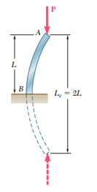 | 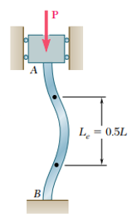
Pinned-Pinned column  $$P_{cr}=\frac{π^{2}EI}{{L_{e}}^{2}} ≪≪L_{e}=L≫≫$$ | Fixed-Pinned column  $$P_{cr}=\frac{π^{2}EI}{{L_{e}}^{2}} ≪≪L_{e}=\frac{L}{\sqrt{2}}≫≫$$
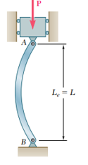 | 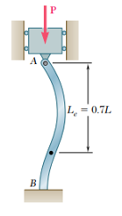

A 3m column with the cross section shown is constructed from two pieces of timber, that act as a unit. If the modulus of elasticity of timber is $E=13 GPa$, determine a) The slenderness ratio
b) Critical buckling load
c) Axial stress in the column when the critical load is applied. Assume all the four end conditions.

References
- Mechanics of Materials, 2/e, J. M. Gere & S. P.Timoshenko, CBS Publishers.
- Mechanics of Materials, 6/e, F.P. Beer & E. R. Johnston, McGraw Hill
- Engineering Mechanics of Solids, 2/e, E. P. Popov, Pearson Education Asia.
- Mechanics of Materials, 9/e, R. C. Hibbeler, Prentice Hall.

